Home Depot Supply Chain Management
Institution’s Name
Student’s Name
Date

Home Depot Supply Chain Management
Introduction
The supply chain of any business is a vital part of its logistics and operations. The significance or purpose of a supply chain is primarily to improve efficiency in the process of meeting the market demand for a product or range of products. Without the supply chain, products would be distributed to wholesalers, retailers and direct consumers in a disorderly and disorganized manner. Such an inefficient process of supplying products where the product distributor such as a warehouse or godown provides the products without a schedule, and without an optimized route for the drivers would lead to monumentally massive overhead costs, delays in deliveries to customers which would mean less business in general. The worst-case scenario, and yet still a realistic scenario for such a company, would be its quick demise and collapse out of a market. Suffice it to say that no business is worth venturing into without a sufficiently competent supply chain and its proper logistics management set in place as it would only be a matter of time before its collapse.
As necessary, therefore, as a supply chain is, it is useless to have a supply chain in place without a proper management strategy for it. Such a supply chain, though more effective than none at all, would still lead to the business incurring losses and bleeding out money. It is integral, therefore, that a supply chain is appropriately managed and governed with regular performance assessments for all the elements of the supply chain to always operate optimally. An excellent example of a business that has exceled in establishing a proper and effective supply chain for itself is Home Depot. Following an expensive restructuring of its supply chain and its management, Home Depot has had an outstanding performance in its market and has grown tremendously as a business. This essay shall delve deeper into examining the specifics of Home Depot’s supply chain management plan and how its restructuring has enabled it to succeed.
For a business to have an adequate supply chain, various factors must come in play. Some of these factors are market studies, demand forecasting, awareness of retail network and the efficiency of order fulfilment by current suppliers.
Market Study
A market study is essential before a supply chain can be set up and implemented. Without a working knowledge of the prevailing market conditions, businesses may find themselves treading on dangerous grounds once the rubber meets the road. The importance of a market study cannot be overemphasized. For some businesses, a market study is all it takes to disprove the viability of pursuing a business venture any further in a particular geographic location. Market studies are usually used to show whether there is room in the market for a business in a specific niche and are therefore necessary.
Demand Forecasting
Demand forecasting is similarly a prerequisite before a supply chain can be implemented. It is necessary to know if the market will respond positively when the business’s products are introduced into it, or if they are already present in market and business operations will only serve to increase supply and reduce the products’ prices.
Retail Network
As for the retail network, it is crucial to be aware of the existent retail system before implementing a supply chain, as this factor widely affects the logistics of the supply chain. If the retail network is located far away and the cost and time for deliveries to be made would be too high and too long respectively, then it is inadvisable to establish the business operations in that locale.
The Impact of Relationships with Suppliers
It is also crucial for a supply chain manager to continually be aware of the dynamics that govern business-suppliers relationships. If a supplier begins to slack off and fail to deliver the required stock within the set appropriate time, then considerations to obtain a new supplier for the affected products must be made. On the other hand, if the working relationship with a supplier is good, it would be prudent to approach them and make an official request for volume discounts where applicable.
Essentially, it is integral that whatever decisions are taken by the supply chain manager be for the best interest of the supply chain and the business at large. In this way, business operations will be optimized, overall running, overhead, and operational costs will be relatively lower, and thus the business will be more profitable. If the supply chain manager is incapable of doing what is best for the business in these ways, then the converse will hold and the evidence for which shall be the slow but sure demise and collapse of the enterprise or business.
Home Depot as a Company
The Home Depot Inc. was inaugurated in 1978 and is based in Cobb County, Atlanta, Georgia in the USA. It is the largest retailer dealing with the home improvement theme in the United States. Home Depot is also the world’s largest brick and mortar retailer (Crawford et al., 2018). Home Depot sells mostly products and offers services related to the field of construction such as construction supply tools, building materials, garden and lawn products and general home improvement goods. Home Depot’s website can be found at https://www.homedepot.com/. Their primary customers are people highly interested in do-it-yourself (DIY) projects, do-it-for-me (DIFM) projects, hobbyists as well as professional customers. As of the end of the fiscal year of 2018, Home Depot had approximately 16 million active customer accounts and so have quite a substantial customer demographic (Home Depot Annual Report, 2018).
Home Depot’s Cost of Goods Sold (COGS)
Home Depot’s cost of goods sold has increased significantly over the past few years. The Cost of Goods Sold (COGS) of a company gives an indication of how much money the company spent in procuring the goods that it sold. In 2016, Home Depot’s COGS, including depreciation and appreciation of fixed assets, was $59.94 billion, while just three years later in 2019, it soared to $72.91 billion (Market Watch, 2020). Their growing COGS also indicates that their operations and supply chain management structure is currently sustainable.
Home Depot’s Supply Chain and its Evolution over Time
Today, Home Depot’s supply chain is a highly enhanced version of what it used to be. The company has made great strides in improving its supply chain and its management having poured in colossal capital investments into this effort. These overwhelming investments have paid themselves off. As of August 2018, Home Depot was planning another overhaul on their supply chain and its management, and it was to set back the company a whopping $1.2 billion over a five year period (Stratton, 2018). The company, because of the lower running and overhead costs availed to it by its restructured supply chain scheme, has become vastly more profitable than it was before the change occurred. It has set itself up as an example to other businesses of proper supply chain management and the rewards that can bring to a business.
In the past, Home Depot used to capitalize on having numerous branches distributed ubiquitously throughout the United States. This strategy worked well for Home Depot in the past as it grew in popularity, and since it had high quality customer service, also became loved over the years. Customer loyalty was high, and it would show in their annual turnover and sales reports. They frequently and typically boasted of turnovers that were to the tunes of several tens of millions of US Dollars. With time, however, things began to change. Markets evolved, and with that evolution, businesses also had to develop or be left behind.
Home Depot realized that its strategy for having numerous branches all over the USA map had its disadvantages despite its fulfilling advantages that they had reaped over the years. An operational change was needed in the supply chain if Home Depot was going to continue swimming in the market’s tides. Various aspects are vital to Home Depot’s success in supply chain management. Some of these are their planning, sourcing, execution, delivery, and return. Each of these five specific aspects shall be delved into further in the section below.
Planning
Home Depot works with several suppliers of construction equipment and companies geared towards manufacturing home-improvement items as opposed to manufacturing these products and items themselves. Home Depot essentially provides the link between those suppliers and a vast customer base worldwide. Thus, it is a win-win situation for all parties involved. They have massive warehouses that have as well undergone various reforms. They have equipped their warehouses with state-of-the-art technology such as a warehouse control system. The system ensures that components arrive and are arranged correctly in their packing areas for multi-line orders. It also works to balance the work at packing stations that are single-line and even at light-directed put walls that are multi-line. In terms of delivery, they have implemented what they term as RDCs (Rapid Deployment Centers) that have tremendously contributed to the speedy processing and distribution of their inventory. With such developments in place, Home Depot has been able to achieve omnichannel capabilities of inventory distribution within its supply chain.
Sourcing
Sourcing is a crucial part of the supply chain. Without competent suppliers to consistently provide goods and inventory, the reputation and business operations of Home Depot run the risk of capsizing. Home Depot and any business really, must ensure that they work with credible suppliers and manufacturers who will not fail to deliver the goods promised and do so on time. Home Depot sources its products both locally within the United States and also abroad, importing some of its products. Quality assurance and control are essential in this process as defective goods must be returned to the suppliers, and Home Depot receives only goods that meet the set quality standards.
In this way, Home Depot ensures that the goods it sells to consumers are of the highest quality which is vital because Home Depot offers consumers the option to return defective goods or goods they are not satisfied with. Given this provision, it would be detrimental for Home Depot if a significant number of their products were flawed as they are the ones who carter for the overhead costs of returning that defective stock. Quality control and assurance is, therefore, an important consideration and goes hand-in-hand with sourcing.
It is also crucial for businesses to source their goods from suppliers that supply the products at lower prices while not compromising on the quality of the products. Lower-priced products give a business a competitive edge over other companies in the market, and this is part of what Home Depot attempts to do as well. A business’s supply chain is only as strong as its supplier base (Salam & Khan, 2018). To ensure a well-functioning product-sourcing structure a Material Resource Plan (MRP) is needed.
Home Depot’s Material Resource Planning (MRP)
Many of Home Depot’s suppliers are some of the most trusted and resourceful brands in the world and include Masco (MAS) found at: https://masco.com/, Fortune Brands Home & Security (FBHS) (found at: http://www.fbhs.com/ ), Scotts Miracle-Gro (SMG) (found at: http://www.scottsmiraclegro.com/) known for providing garden and lawn care products. Others that supply to Home Depot are Mohawk Industries (found at: https://www.mohawkind.com/ ) that provide carpets and flooring material for homes and Cree that provides lighting devices and appliances for homes and is found at: https://www.cree.com/ . By aligning themselves with these manufacturers and suppliers and more, Home Depot is able to supply a vast range of home-based products for those in the construction industry as well as for home enthusiasts, hobbyists, DIY, DIFM project enthusiasts and professionals alike.
Execution
The execution and manner in which the new reformations were implemented would be just as crucial as the reformations themselves. If done sloppily and lazily, they would be rendered useless to Home Depot and would not help the business in any way. If, however, they were implemented well, they would see the rapid growth of the business and significant increases in profitability – and they did. So much so did Home Depot succeed at streamlining their operations, that same-day order fulfilment became possible especially for small parcels – where it had been previously believed to be an unattainable goal.
The executory organization of the orders is complex. The execution and fulfilment of orders are done using their latest concept of Direct Fulfillment Centers (DFCs). There are several stages involved in the implementation of orders in Home Depot. These stages are as outlined: receiving, replenishment, order fulfilment, picking non-conveyable items and conveyable items, consolidation and shipping or packing (Bond, 2015).
The execution stage is highly organized, and workers are assisted where possible with lightly automated machinery and equipment. Work flows seamlessly from station to station and from stage to stage throughout this process as the orders are fulfilled. For instance, in the pick modules, workers (called pickers) are voice-directed or use radio-frequency communication (through walkie-talkies) when working in the bulk floor (see first attached pictorial illustration) where bulky products are stored. Also, the warehouse control system examines the status and current conditions of product flow in the picking stations and optimally organizes products for the most efficient workflow. These measures dramatically improve efficiency by preventing product bottlenecks at the stations and ensure all the workers are engaged in useful work.
Delivery and Transportation
The delivery sector of Home Depot has undoubtedly seen the most reformation as it is an integral part of the company’s supply chain. In previous years Home Depot’s stronghold was its large number of branches all over the United States. This model eventually proved insufficient and inefficient, and thus reforms surrounding the company’s supply chain and its management had to come in place. One of the disadvantages of the previous model of operation and supply chain was the high running costs they would incur due to inventory and stock distribution. Their inventory distribution model was unconventional at the time. While rival businesses such as Wal-Mart and Lowe’s went with the conventional Distribution Centers (DCs) that served various branches and company stores in the country, Home Depot went the Less-Than-Truckload (LDL) route.
The Less-Than-Truckload (LDL) Method
The Less-Than-Truckload (LDL) is a method of shipping that businesses choose to mitigate the risks they run when trusting suppliers to respond to purchase orders in due time to meet customer demands. This method may be especially preferred for customers or consumers who live in distant regions. It is an efficient method for shippers of small-sized items and relatively small quantities of freight such as parcels and not for bulky goods. Generally, they consist of products that weigh between 15 and 15,000 pounds and occupy a maximum of about 24 feet of a trailer truck and are usually not more than just six pallets (Segal, 2019). Although this method offers more inventory availability and reliability to the consumers, the overall costs for shipping are significantly higher, and the time it takes for the trailer trucks to deliver the goods or inventory may be longer. These seemingly slight disadvantages take a toll on the business over time and lead to higher running, acquisition and holding costs.
Part of the reforms brought into Home Depot’s supply chain was the cessation of the Less-Than-Truckload (LDL) method for the shipping of their goods, and they embraced the more conventional distribution structure. Formerly, Home Depot was using the LDL method to turn country-wide stores into fulfilment centres essentially. While that is an interesting approach, the stores were simply not designed for such a dual purpose and what started happening is that workers would compromise on customer service to ensure a steady flow of order fulfilment for products. This measure was accompanied by setbacks and losses as customers would leave disgruntled and Home Depot’s reputation was highly at risk.
Generally, to ensure a more robust supply chain as well as better customer service, Home Depot adopted the RDC model to centralize their distribution to stores within particular locales regionally. Home Depot also constructed three major DFCs (Distribution Fulfillment Centers) which would further facilitate this process. These DFCs are large and hold a lot of inventory for replenishing stock in various stores. The DFCs managed to do this by leveraging inventory with omnichannel mathematical algorithms for optimal solutions (Bond, 2015).
One distinct advantage of this method is speedier deliveries to customers, leaving them more satisfied with Home Depot’s service and thus they would be loyal to Home Depot and thus sales soared. Another delivery channel that significantly boosted sales was Home Depot’s online store which made the shopping experience vastly easier and simpler for the customers. The customers can check whether specific goods are available in particular stores and their in-store aisle locations and positions. This online store further strengthened sales and made even more use of Home Depot’s supply chain.
Return
Home Depot provides customers with the chance to return goods and products they are not satisfied with for whatever reason or that are defective. Home Depot must investigate the quality of all goods returned to determine the legitimacy and credibility of the customer’s claim to a refund. Goods may also be reordered or replaced according to customer’s requests. Home Depot does incur some costs, however, with returned products such as record-keeping costs and editing the records to reflect the return of those goods. Being a detrimental outcome, therefore, Home Depot is largely concerned with the quality control of products to ensure the highest quality standards for their customers and consumers.
Recommendations
In 2006, Home Depot bought a dozen stores in the home-improvement scene from a local Chinese company called Home Way. Only six years later, business in China was slower than ever and these stores only contributed to about 0.3% of Home Depot’s annual net sales and were therefore closed (Shedd, 2019). The failure was attributed mainly to insufficient market research and deficient research on consumer needs. Thus, it is my recommendation that for any future expansion projects by Home Depot, extensive research, market study and consumer needs be carried out in depth. Such thorough research will ensure a repeat of their failure in China does not recur and will also provide insight into how they should approach specific markets and consumers.
Conclusion
Home Depot has invested in its operations and supply chain management, and the result of this is high earnings and increasing sales. Their projected revenue for 2020 was $120 billion. All the five stages listed and explained above are crucial to the supply chain management and must be implemented concurrently to ensure optimal results. Business managers should endeavor to follow these necessary steps in the supply chain process to keep their organizations and businesses running in the dynamic and ever-changing market scenario.

Below is a pictorial illustration of Home Depot’s supply chain within the warehouse and also included below that is an illustration of their omnichannel supply chain strategy.
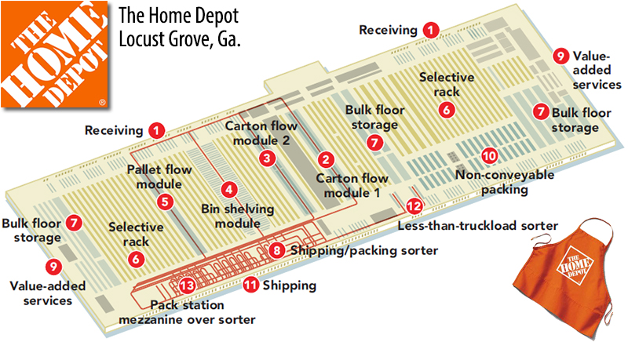

Omnichannel Supply Chain strategy illustrated below:
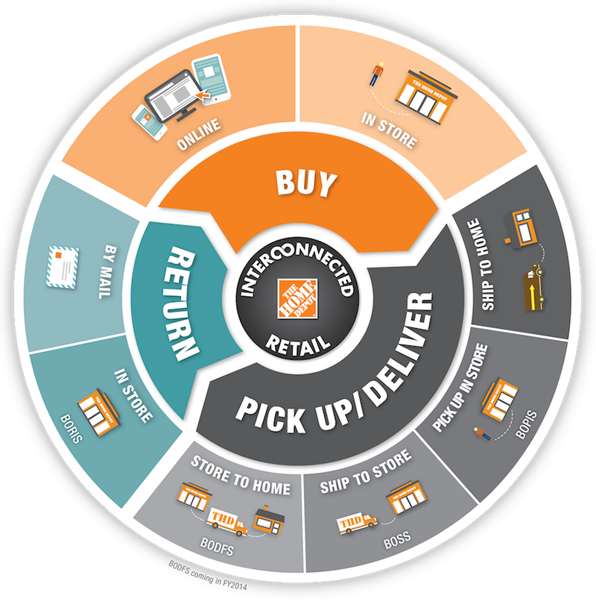
References
Bond, J. (2015). The Home Depot builds an omni-channel supply chain. Modern Materials Handling, 78, 21-24.
Crawford, T., Harrison, T., & Markow, A. (2018). The Home Depot.
Market Watch. 2020. Annual Financials for Home Depot Inc. Retrieved through: https://www.marketwatch.com/investing/stock/hd/financials
Salam, M. A., & Khan, S. A. (2018). Achieving supply chain excellence through supplier management. Benchmarking: An International Journal.
Shedd, K. (2019). Why Home Depot failed in China. Retrieved through: https://www.cnbc.com/2019/06/14/why-home-depot-failed-in-china.html#:~:text=In%202006%2C%20Home%20Depot%20bought,12%20stores%20in%20the%20country.&text=Analysts%20say%20that%20Home%20Depot,on%20consumer%20needs%20and%20culture.
Stratton, F. (2018). Home Depot Builds New Supply Chain. Retrieved through: https://www.inboundlogistics.com/cms/article/home-depot-builds-new-supply-chain/
The Home Depot. (2018). The Home Depot Annual Report. Retrieved through: https://ir.homedepot.com/~/media/Files/H/HomeDepot- IR/2019_Proxy_Updates/HDAnnualReport2018.pdf

